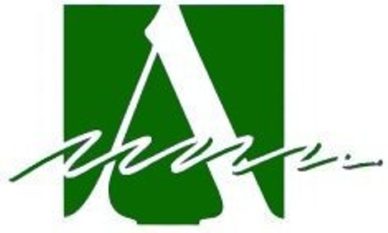

Area Agency on Aging, PSA2
2025 Bid Process

Letter of Intent Guidance

For Evidence Based Services:

The Area Agency on Aging, PSA 2 (AAA) seeks Letters of Intent from service providers who are interested in receiving a contract for fiscal year 2025 ending Sept. 30, 2025 through a competitive Request for Proposal process to provide specified services under the following programs.

- Older Americans Act Title III-D Evidence-Based Programs
All contract awards are for the period of January 1, 2025– September 30, 2025.

The availability of funding for each program is contingent upon the annual funding authority received by the Area Agency from the Ohio Department of Aging and any changes imposed at the State level. Programs are for sites and communities within Champaign, Clark, Darke, Greene, Logan, Miami, Montgomery, Preble and Shelby counties. The contract is awarded on a cost-reimbursement basis — no unit rate is assigned.

The application process is as follows:

1. Select Letter of Intent (LOI) form posted on Area Agency Website and complete all the information requested on the LOI. Please refer to the Planned Funding Levels at the end of this guidance for the available funding and services.

2. The Applicant must email the LOI by February 7, 2025, not later than
11:59 pm to the email address on the LOI. Late LOIs will not be accepted.

3. Important: Application packets will be sent electronically only to agencies who submitted an LOI by requested due date of February 7, 2025.

4. Agencies who submit LOI by due date will receive notice of an informational session to be held via Zoom: Feb. 14, 2025 at 1:30pm. The purpose of the Informational Session is to review the proposal packet and answer any questions. Attendance at the informational session is not required.

5. Submit proposal to the Area Agency per proposal packet instructions. Proposal must be received at the Area Agency office electronically no later than Friday, March 10, 2025 no later than 11:59 pm. Late proposals will not be accepted.

Contact: Karin Nevius, Wellness & Communications Supervisor, knevius@Info4seniors.org, 937-341-3001.

Planned Funding Levels

Regional program (any or all of region) | Planned Annual Funding
Champaign County | $7,676.94
Clark County | $16,630.85
Darke County | $8,934.51
Greene County | $16,848.93
Logan County | $8,400.13
Miami County | $12,923.35
Montgomery County | $49,697.82
Preble County | $7,980.69
Shelby County | $8,162.79
Area Agency on Aging, PSA2 TOTAL | $137,256.01

******See Next Page: Contracting Schedule in 2025*****

2

Allocation Contracting Schedule in 2025
For Older Americans Act Services Funding
January 2025 – September 2025

Jan. 22 The AAA Advisory Council and Board of Trustees approve the
funding formula and the plan for Competitive Bid Process.

Jan. 23 The AAA announces planned 2025 service allocations and requests Letters of Intent due at the AAA office. Applications mailed.

Feb. 7 Letters of Intent due at the AAA office. Application packets mailed.

Feb. 14 Online informational meeting about proposal applications for III-D
funds.

March 10 Completed application packets/proposals due to AAA office.

Ad hoc committee formed to review proposals.

March 26 Agency staff present recommendations to the AAA Advisory Council. Upon Advisory Council review, Council submits recommendations for Board of Trustees approval.

April 9 The last day for organizations to appeal contracting decisions for
III-D funding.

April 10 Fund recipients notified.

3

