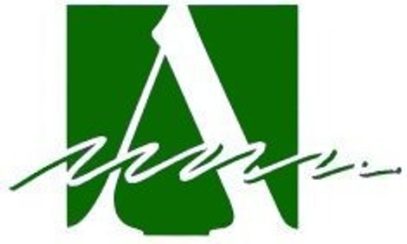

Area Agency on Aging, PSA2

State Funding Year 2025

Letter of Intent

for

IIID Evidence-Based Programs

in a Nine-County Area of Service

Note: The availability of funding and allowable services is contingent upon the annual funding received by the Area Agency from the Ohio Department of Aging and any changes imposed at the State level.

1. Complete the following information for your organization:

Agency Name:
Contact Name:
Address:
City, State, Zip:
Phone Number:
Fax Number:
Email Address:
EIN: (Employee Identification Number)

- Type of Agency: (Check all that  apply) | - Type of Provider:
  Governmental:
  For Profit:
  Non Profit:
  Minority Agency:
  Senior Center:
  Parks&Rec/YMCA:
  Long Term Care Facility or Retirement Comm.:
  Other (specify):
3. Does your agency have a local office in the nine-county service area of
Champaign, Clark, Darke, Greene, Logan, Miami, Montgomery, Preble, and Shelby and a toll free number telephone number? Please provide address(es) of the local county office(s) and toll free number.

4. Does your agency have Board-approved policies and procedures that support your service?
Yes: |  | No:

Comments:

5.
Submit Letter of Intent electronically to:
Email: knevius@info4seniors.org
cc: snelson@info4seniors.org

Fax: 937-341-3005

Must be received by Feb. 7, 2025

Important: Applications for IIID Evidence-Based Programs will be sent electronically only to those organizations who have submitted a letter of intent by Feb. 7, 2025. Questions should be directed to the email address above.

DUE DATE FOR LETTER OF INTENT: Feb. 7, 2025

