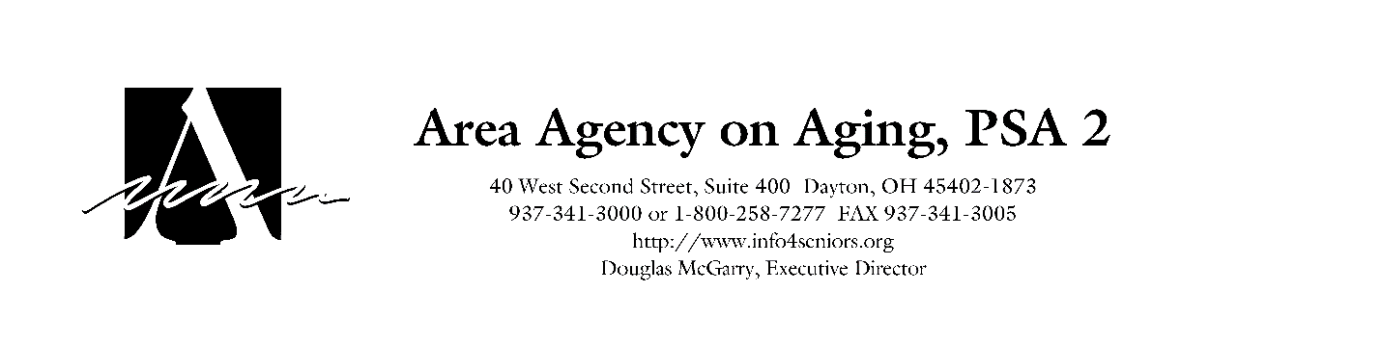

**Alzheimer’s Family Support Services**

**2025-2027**

**Letter of Intent**

**Note: The availability of funding and allowable services is contingent upon the annual funding received by the Area Agency from the Ohio Department of Aging and any changes imposed at the State level in the new biennial budget beginning July 1**.

|  |  |  |  |  |  |  |  |  |  |  |  |  |  |  |  |  |  |  |
| --- | --- | --- | --- | --- | --- | --- | --- | --- | --- | --- | --- | --- | --- | --- | --- | --- | --- | --- |
| **1. Complete the following information for your organization:**     |  |  | | --- | --- | | **Agency Name:** |  | | **Contact Name:** |  | | **Address:** |  | | **City, State, Zip:** |  | | **Phone Number:** |  | | **Fax Number:** |  | | **Email Address:** |  | | **EIN: (Employee Identification Number)** |  | |  | | |
| 1. **Type of Agency: (Check all that**   **apply)**   |  |  | | --- | --- | | **Governmental:** |  | | **For Profit:** |  | | **Non Profit:** |  | | **Minority Agency:** |  | | 1. **Type of Provider:**  |  |  | | --- | --- | | **Alzheimer’s Association:** |  | | **Senior Center:** |  | | **Long Term Care Facility:** |  | | **Other (specify):** |  | |  | | |

**3. Does your agency have a local office in the nine-county service area of**

**Champaign, Clark, Darke, Greene, Logan, Miami, Montgomery, Preble, and Shelby and a toll free number telephone number? Please provide address(es) of the local county office(s) and toll free number.**

|  |
| --- |
|  |

**4. Does your agency have Board approved policies and procedures that support**

**your service?**

|  |  |  |  |
| --- | --- | --- | --- |
| **Yes:** |  | **No:** |  |

***Comments:***

|  |
| --- |
|  |

**5.**

**Submit Letter of Intent electronically to:**

|  |
| --- |
| Email:  cherdman@info4seniors.org  Fax: 937-341-3005  **Must be received by April 11, 2025** |

**Important: Applications for Family Support Services will be sent electronically *only* to those organizations who have submitted a letter of intent by April 11, 2025. Questions should be directed to the email address above.**

**DUE DATE FOR LETTER OF INTENT: April 11, 2025**